**1. Homepage 1**

1.1 Environmental Justice (EJ) Atlas 1

1.2 Map Centered 3

1.3 Map as the Homepage 4

1.4 Minimized Map 5

1.5 No Map 6

**2. Map Items 7**

**3. Submission Form 7**

**4. Tutorial 7**

# **1. Homepage**

Based on the website flowchart, the Chesapeake Community Connection homepage should include:

* Logo
* Menu Navigation
* Website Summary
* Login
* Current News/Recent Uploads

The homepage should be able to:

* Make an upload
* Access the Discussion Board
* Access the Map

The map and the filters should remain in the forefront for ease of access. The new website idea has the map remain a blank canvas until the user selects one of the following tags: individual projects, specific project type(s), or projects headed by an organization/person/set of people. Once individual projects have been selected, information about the projects appear at the bottom of the page. The range of the project(s) is/are seen on the map.

## 

## **1.1 Environmental Justice (EJ) Atlas**

The EJ Atlas page has the map on the left with the tab bar layered on top of it. Various options overlay the map, including buttons to other pages.

* Visually clunky - eyes wander all over the page without centering on anything.
* Easy enough to understand, but sections aren’t separated cleanly.
* Standard. Not well-made, not horrible, functions decently.

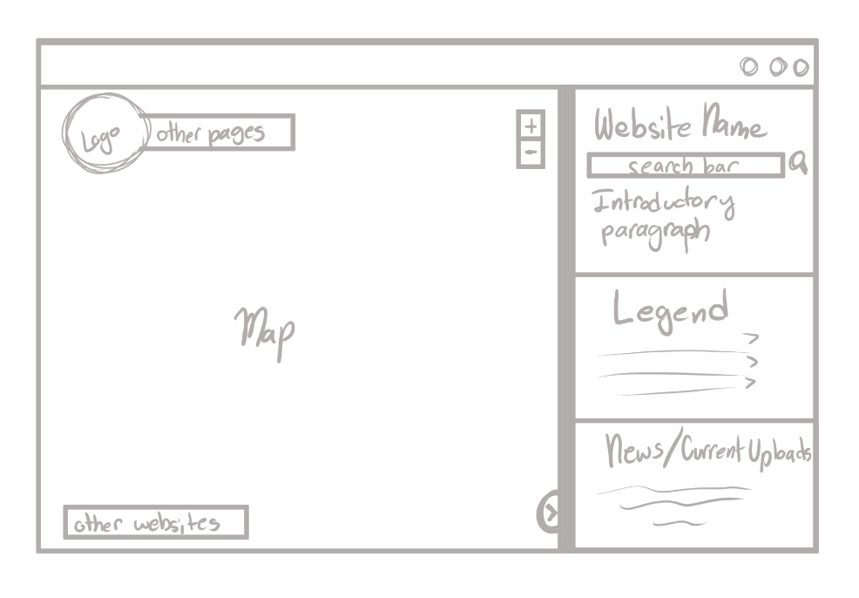

Outside Example: EJAtlas, NASA Wildfire Maps

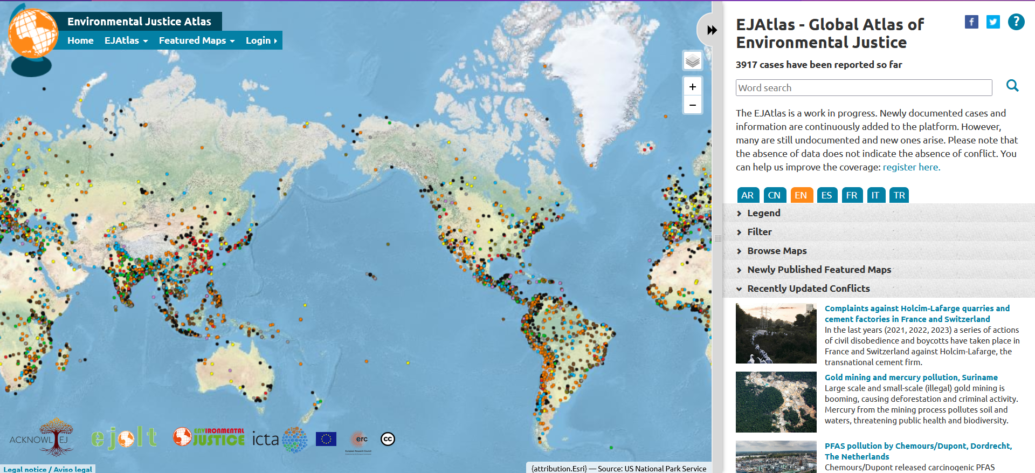

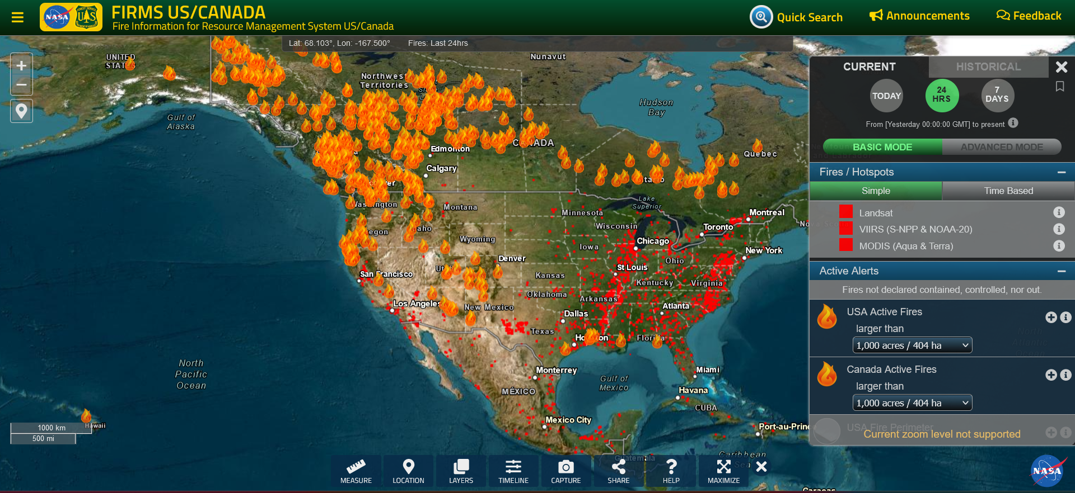

## **1.3 Map as the Homepage**

The map is large and encompasses the entire page. Everything else acts as a pop-up which the user must click in order to fully access. Think of it as a computer

* Eyes center on the map upon entering the website - can be positive or negative based on the individual.
* Not intuitive as a homepage, but still an option.

Drawn Example:

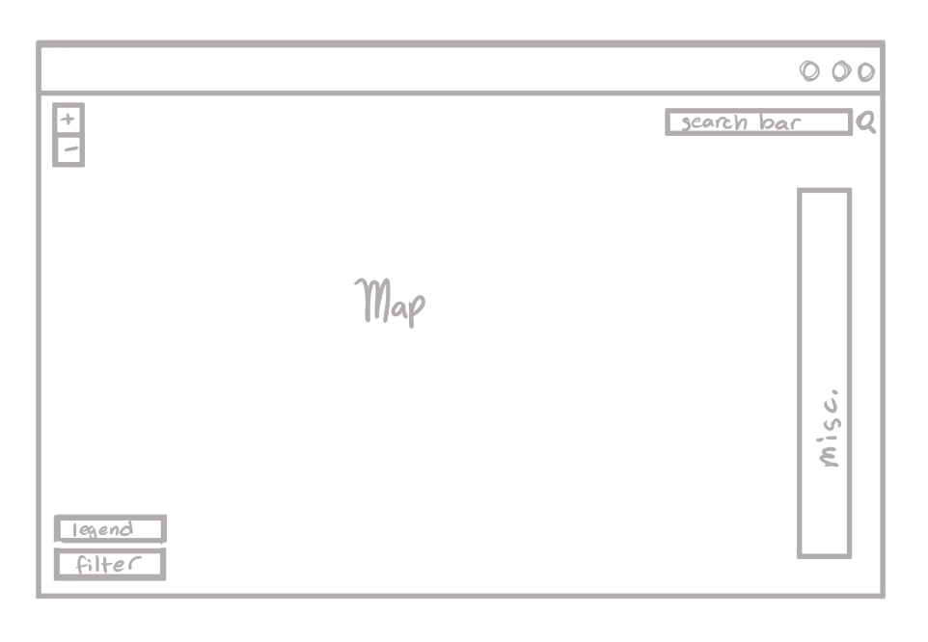

Outside Example: Google Maps, Fire and Smoke Map

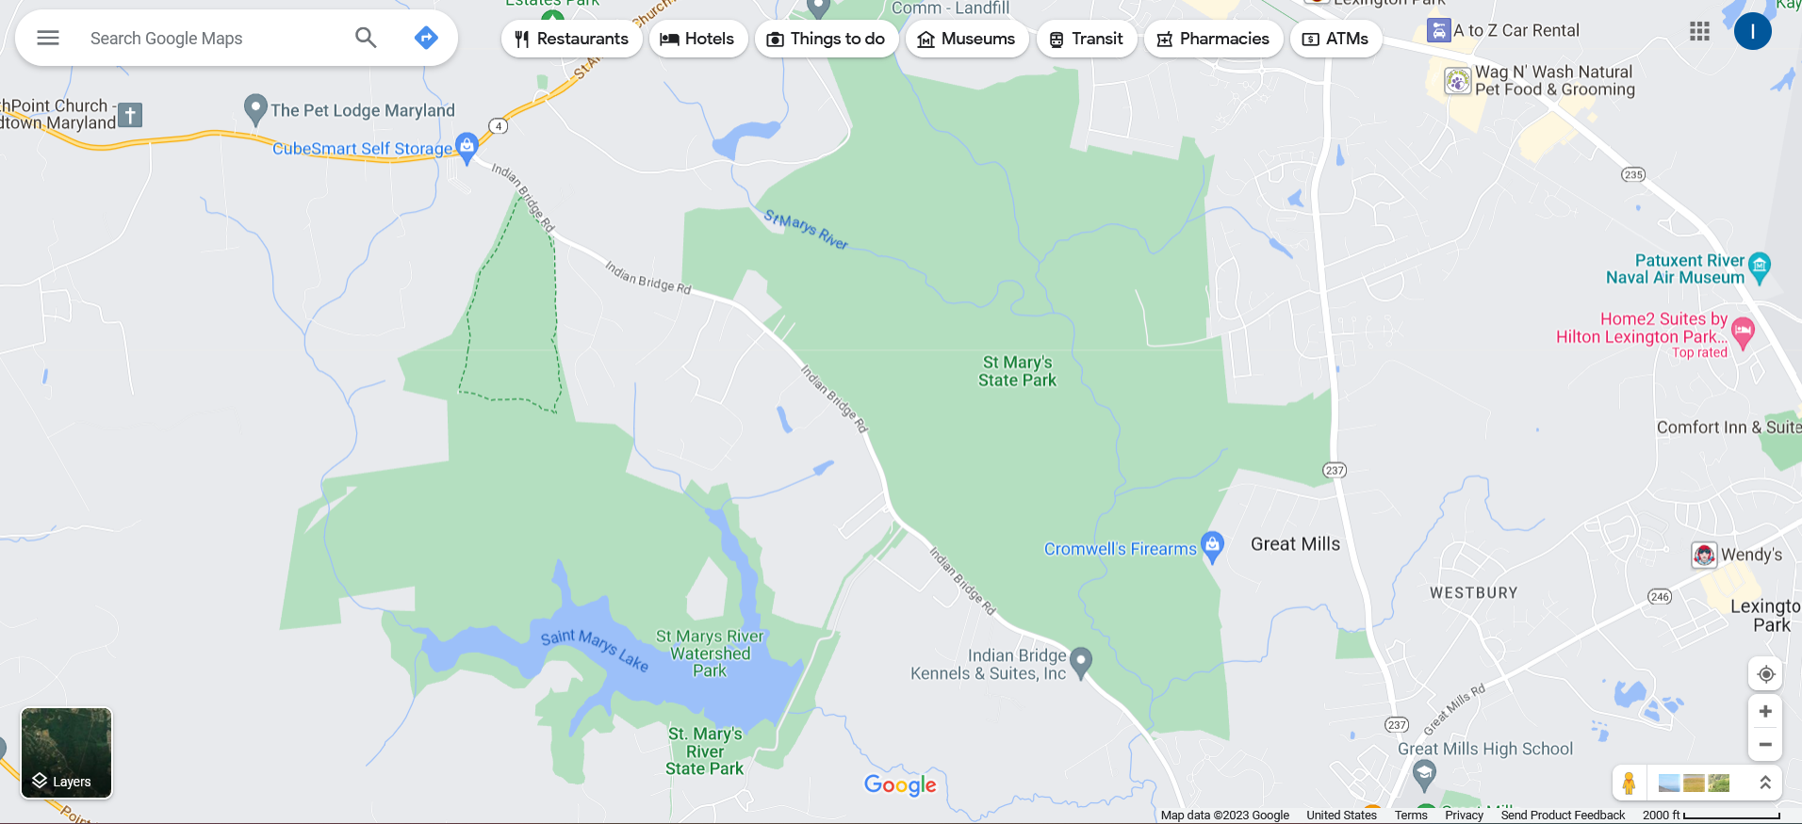

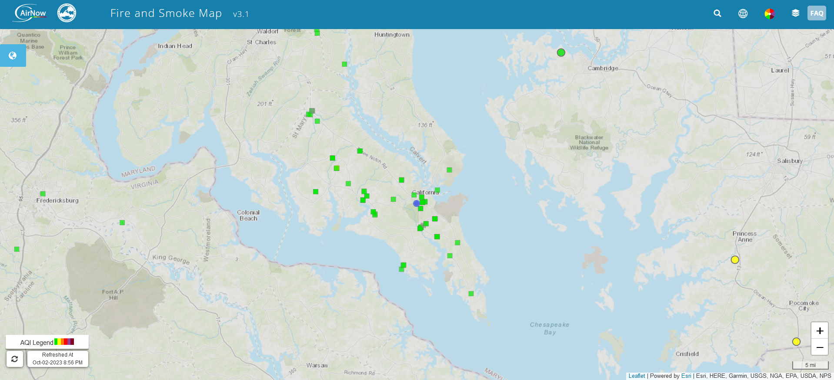

## **1.4 Minimized Map**

The map is in a box or minimized window on the page, but it isn’t the centerpiece of the website. The map may be expandable or not. This one is less messy than the other options.

* Suggested by R&D.

Drawn Example:

Outside Example: Maryland.com

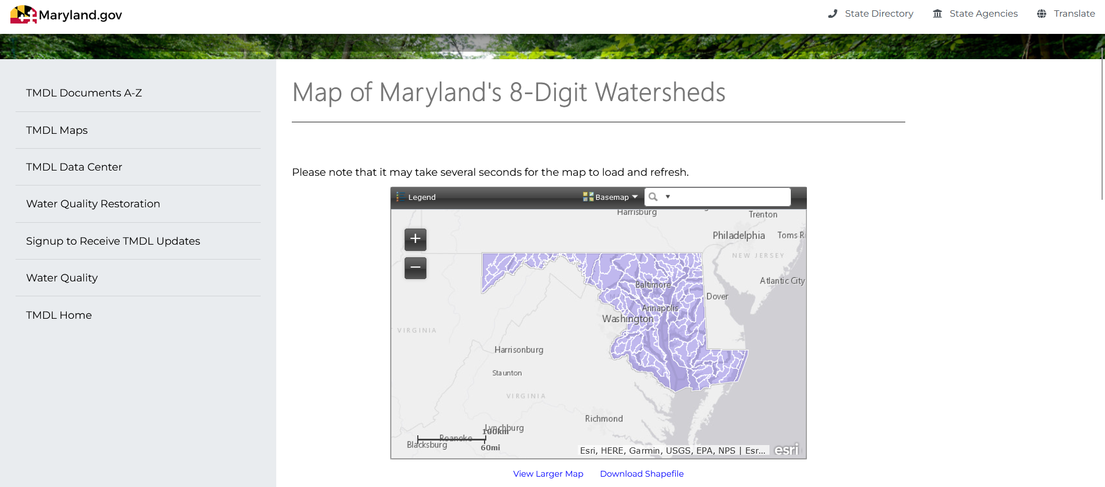

## **1.5 No Map**

There is no map present on the page. The homepage serves as an introduction to the purpose of the website and contains links to all other pages of the website including the actual map and the tutorial. This would be the easiest to implement and is less likely to result in software errors during development.

Drawn Example: Variable. We’d have to go through many examples.

Outside Example: NIFC Maps

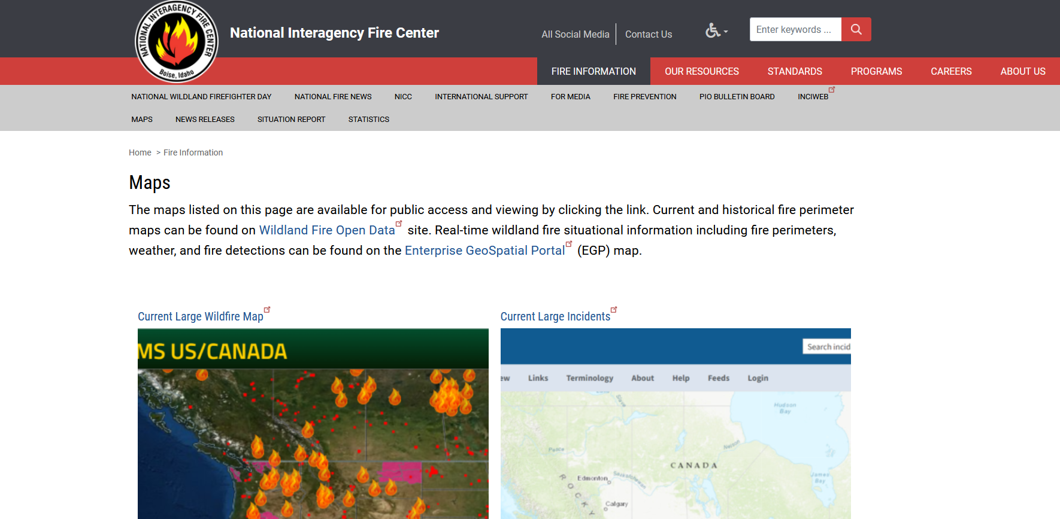

# **2. Map Items**

Pins

Legend

Filter

New Uploads

Multiple Uploads in One Area

# **3. Submission Form**

Date Recorded

Date Uploaded

Uploader - Other Members Present

Organization Association(?)

Description

Audiovisual Upload

Preview(?)

Email Confirmation(?)

What is mandatory? What is not?

# **4. Tutorial**

There are two main types of tutorials: a separate page which shows every feature with a description or a dynamic showing of each feature that the user must click through to progress.

* Is it mandatory for a first visit or not?
* Is the tutorial easily accessible on the homepage or put elsewhere?